**Project Documentation: Exploratory Data Analysis using Python**

**Project Information**

:

:

:

:

:

:

Laptop Dataset Analysis

Moviraj D

May-2025

RP-36

Offline

B2024126094

**Title** : Laptop Dataset

**Name** : Moviraj D

**DA/DS** : May-2025

**Batch Number** : RP-36

**Online/Offline** : Offline

**Roll Number**  : B2024126094

**Table of Contents**

**1. Introduction**

This project explores and analysis various laptop specifications to understand pricing trends and performance characteristics. It involves data cleaning, statistical analysis, and visualizations to uncover market insights.

### 2. ****Aim****

To identify the key specifications influencing laptop prices and extract insights about performance, trends, and brand dynamics in the laptop industry.

### 3. ****Business Problem / Problem Statement****

Consumers and businesses face difficulties in choosing laptops due to varying specifications and prices. This project aims to:

* Identify which features significantly affect pricing.
* Explore relationships among laptop specifications.
* Recommend strategies based on data-driven insights.

### 4. ****Project Workflow****

1. Data Collection
2. Data Cleaning & Preprocessing
3. Exploratory Data Analysis (EDA)
4. Feature Engineering
5. Statistical Testing
6. Visualization & Insights
7. Conclusion

### 5. ****Data Understanding****

The dataset includes laptop specifications like:

* Company
* TypeName
* Inches (Screen Size)
* Weight
* CPU, GPU, RAM
* Price (Target)

### 6. ****Data Cleaning****

* **Missing Values**: Removed or imputed.
* **Outliers**: Detected using boxplots.
* **Inconsistent Values**: Unified categorical values (e.g., merging "Notebook"/"Ultrabook").

### 7. ****Obtaining Derived Metrics****

* Extracted CPU and GPU brand.
* Extracted processor generation.
* Created binary flags like Touchscreen or IPS panel.

### 8. ****Filtering Data for Analysis****

* Removed extreme outliers in price.
* Filtered brands/types with very low sample sizes.
* Removed duplicates and rows with unclear data.

### 9. ****Statistical Analysis****

### Used **ANOVA** to test if price varies significantly across companies.

python

CopyEdit

from scipy.stats import f_oneway

stat, p_value = f_oneway(*vl.groupby('Company')['Price'].apply(list))

### 10. ****Exploratory Data Analysis (EDA)****

### ****Exploratory Data Analysis (EDA)**** is a crucial step in data analysis that involves visually and statistically examining datasets to uncover patterns, spot anomalies, test hypotheses, and check assumptions. In the context of this laptop dataset, EDA helps understand the distribution of variables like price, RAM, and screen size, and how they relate to one another.

### It includes ****univariate analysis**** (individual features), ****bivariate analysis**** (feature relationships), and ****multivariate analysis**** (interactions among multiple features). Tools like histograms, boxplots, scatterplots, and heatmaps are used to reveal trends, correlations, and outliers that guide deeper analysis and informed decision-making.

### ****Univariate Analysis****

* **Histograms**: For distribution of prices, RAM.
* **Boxplots**: To detect outliers
* **Countplots**: For categorical variables like TypeName.
* **Pie charts**: For brand/RAM proportion.

### 

### 11. ****Bivariate Analysis****

* **Scatterplots**: RAM vs Price, Inches vs Weight.
* **Boxplots**: GPU/CPU Brand vs Price.
* **Violin plots**: Price distribution by type or GPU.
* **Hexbin**: For density in numerical variables.

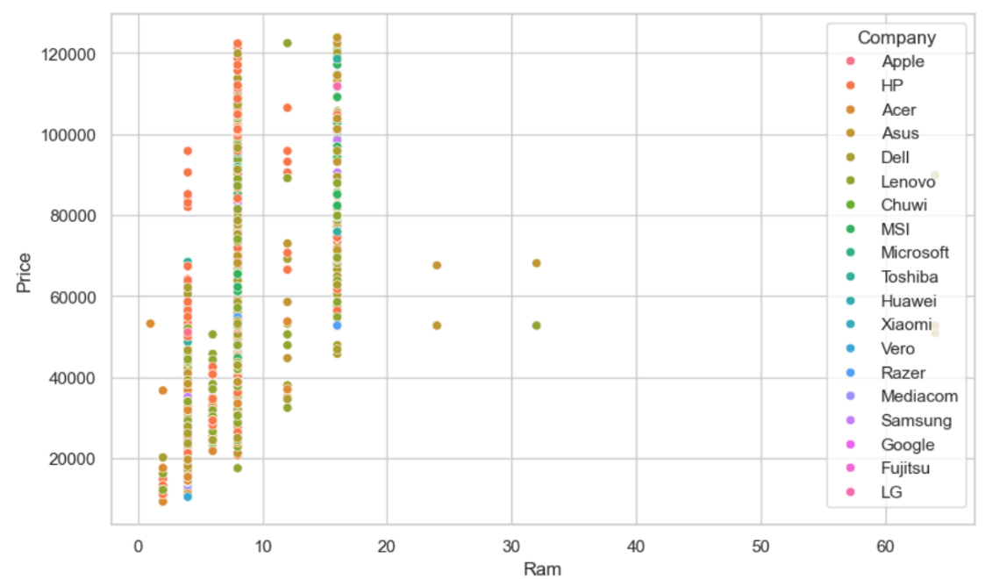

### 12. ****Multivariate Analysis****

* **Heatmap**: To examine correlation.
* **FacetGrid**: For grouped scatterplots.
* **3D Plotting**: Price vs RAM vs Inches using Plotly or mpl_toolkits.

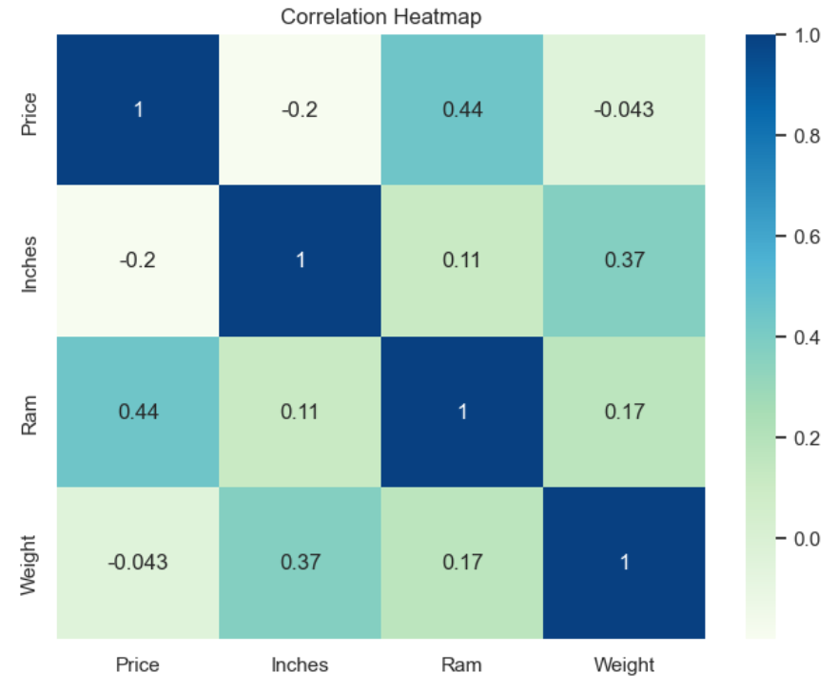

### 13. ****Overall Insights****

* **RAM and CPU brand** are top price influencers.
* **Ultrabooks and Gaming laptops** are costlier.
* **Brand reputation** significantly impacts pricing.
* **Weight and Screen size** are moderately correlated.
* **Intel i7 and dedicated GPUs** increase price significantly.

### 14. Future Engineering

### Extract CPU brand and generation to better group laptops by performance level.

### Flag SSD vs HDD to highlight impact of fast storage on price.

### Categorize weight (light vs heavy) to separate ultrabooks from gaming laptops.

### Group brands by reputation (premium vs standard) to see how brand image affects pricing.

### Create new features like screen resolution quality (e.g., Full HD, 4K) for deeper price trend insights.

### 15. ****Conclusion****

The analysis provides actionable insights for consumers and sellers:

* Focus on key specs like RAM, CPU brand, GPU.
* Brands can adjust pricing strategies based on demand trends.
* Consumers can get value-for-money by comparing specs.

**Github link :** [Laptop dataset Analysis Python project](https://github.com/Movi1234/Laptop-python-project)